

|  |  |
| --- | --- |
| **Student Name/ID Number:** | Sebastian Seth R. Escarro – BDSE-0922-118 |
| **Academic Year:** | 2023 - 2024 |
| **Unit Assessor:** | Ei Thandar Khaing |
| **Project Title:** | Power BI Data Preparation and Data Transformation |
| **Issue Date:** | 25-Nov-2023 |
| **Submission Date:** | -Nov-2023 |

|  |
| --- |
| **Learner declaration** |
| I certify that the work submitted for this assignment is my own and research sources are fully acknowledged.      Student signature:  Date: November 28, 2023 |

## Create a new column to calculate the body mass index (BMI) for each individual in the

## dataset.

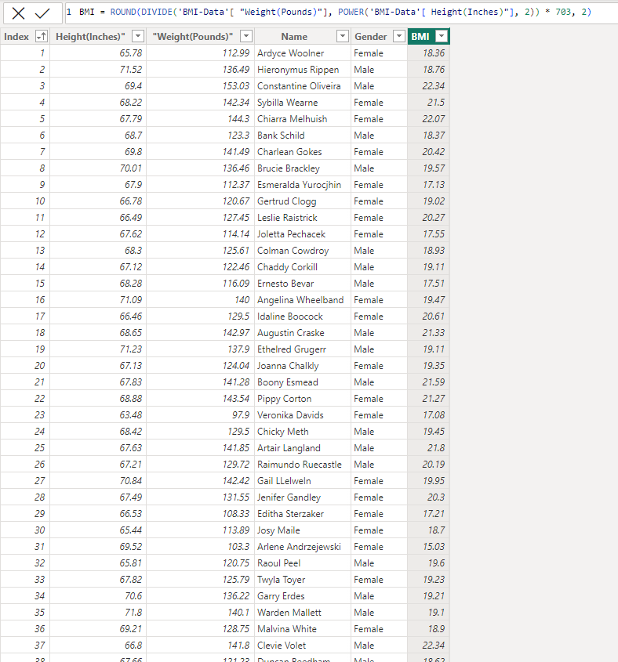

## Create a pivot table to display the average height and weight by gender.

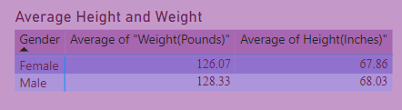

## Create a chart to display the distribution of BMI in the dataset.

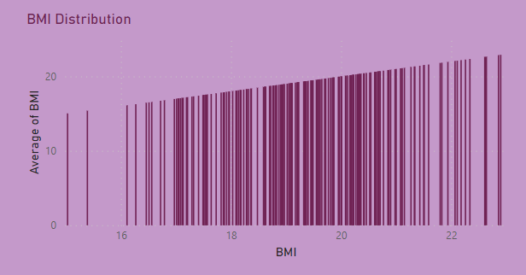

*Line and Stacked Column Chart*

## Use conditional formatting to highlight the individuals with a BMI over 20.

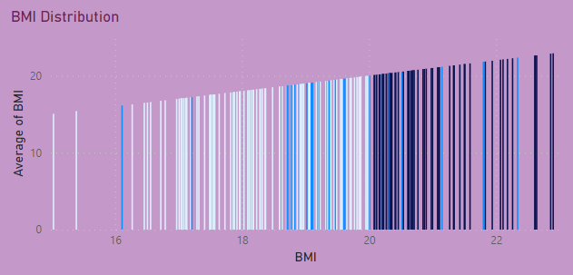

*Darker colors are over 20*

## Create a new sheet to display the summary of the data, including the average height and

## weight, the maximum and minimum height and weight, and the number of individuals in the dataset.

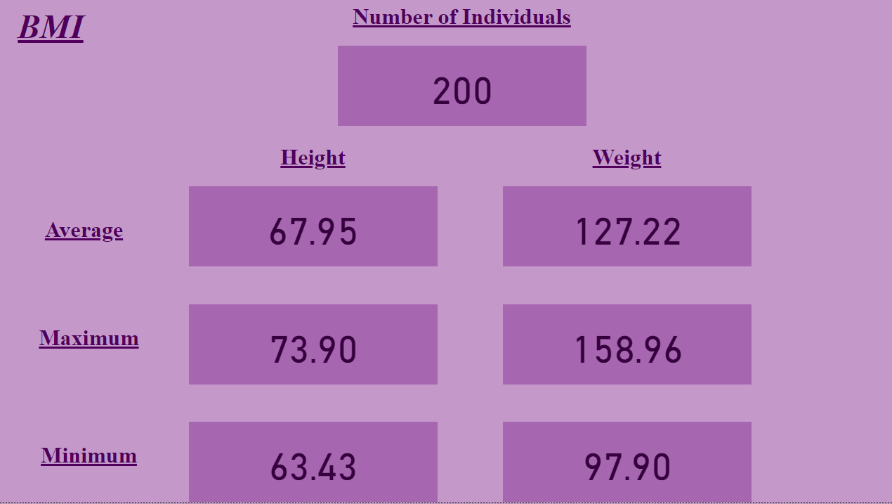

## Create a calculated column to categorize the individuals in the dataset by BMI range (e.g.,

## underweight, normal, overweight, obese).

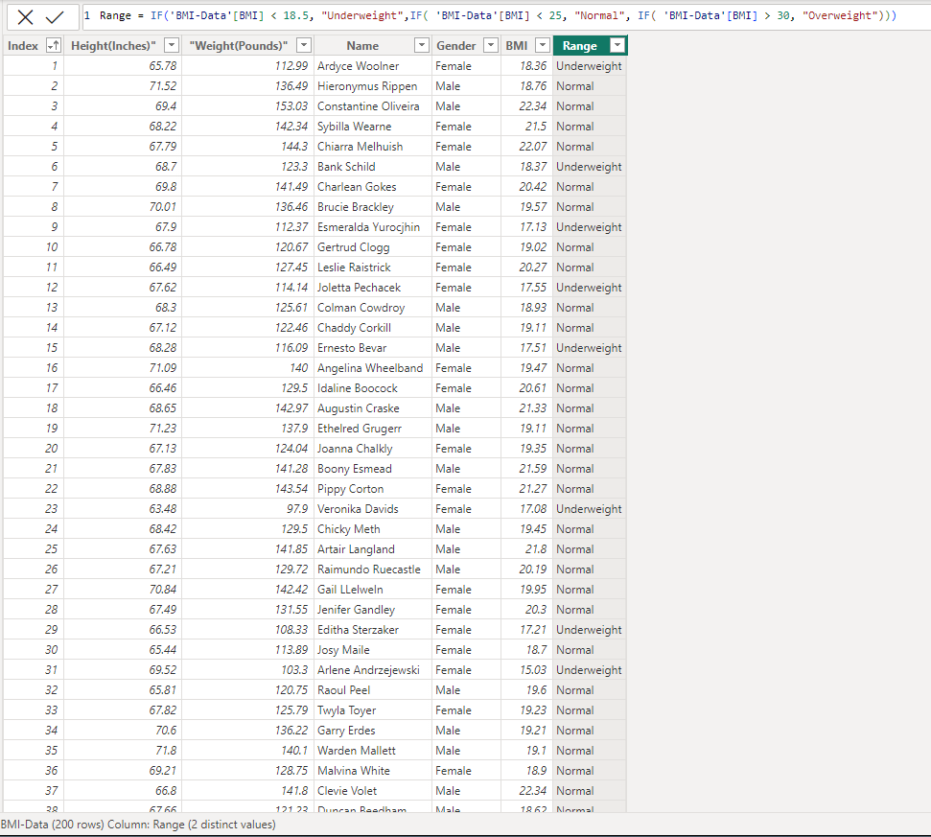

## Filter the pivot table to show only the individuals with a BMI over 18.5.

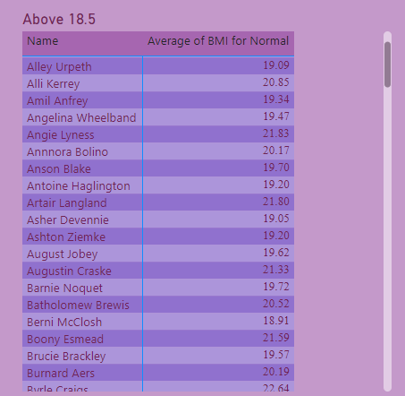

*Using Above 18.5 since no BMI pass 25 or 30*

## Create a new table to show the top 10 individuals with the highest BMI, including their

## name, gender, height, weight, and BMI.

